Index
1. Introduction
- 1.1 Project Overview
- 1.2 Objectives of the Project
- 1.3 Aims of the Dashboard
- 1.4 Scope and Importance
2. Dashboard 1: Company Overview
3. Dashboard 2: Company Performance Analysis
4. Dashboard 3: Stock Price & Volatility Analysis
5. Dashboard 4: Trading & Transaction Insights
6. Conclusion
- 6.1 Key Insights
- 6.2 Business Implications
- 6.3 Future Recommendations
7. References
- 7.1 Data Sources
- 7.2 Analytical Tools Used

1. Introduction
1.1 Project Overview
The project “Market Performance and Trading Insights” focuses on analyzing market-related data across multiple companies, industries, and financial activities. It aims to combine various datasets, such as company details, stock prices, trading volumes, transactions, and performance metrics, into a unified analytical model.
By integrating and visualizing this data through Power BI, the project provides a clear understanding of company performance, market trends, stock volatility, and trading patterns. This helps in identifying growth opportunities, performance variations, and investor behaviours within the market.
1.2 Objectives of the Project
The main objectives of this project are to:
- To design and implement a relational database that efficiently integrates multiple aspects of market data, including company details, financial performance, stock prices, trading volumes, and financial transactions.
- To ensure data integrity, normalization, and scalability for accurate, consistent, and efficient handling of large datasets across different data sources.
- To enable fast and flexible querying capabilities that support analytical operations such as tracking company growth, identifying market trends, and comparing financial performance across industries.
- To generate data-driven insights by establishing meaningful relationships between stock performance, company profitability, and trading activities.
- To provide a strong analytical foundation for developing interactive visualization tools and dashboards that support decision-making, strategic planning, and research analysis.
1.3 Aims of the Dashboard
The dashboards are designed to simplify complex market data and present it in an easily understandable, visual format.
Each dashboard aims to:
- Dashboard 1 (Company Overview): Display company profiles, industries, and market capitalizations.
- Dashboard 2 (Performance Analysis): Compare revenue, profit, and EPS trends to measure financial health.
- Dashboard 3 (Stock & Volatility Analysis): Highlight price movements and market volatility.
- Dashboard 4 (Trading & Transaction Insights): Examine buy/sell activities, currency distribution, and total transaction amounts.
The ultimate aim is to provide a data-driven view of market behavior and support deeper business insights.

1.4 Scope and Importance
The scope of this project encompasses data from multiple financial aspects, including company information, market performance, stock prices, and trading activities.
By using Power BI, large datasets are organized into meaningful visual insights. The project demonstrates:
- How business intelligence tools can transform raw market data into actionable insights.
- The role of analytics in monitoring company growth and market performance.
- The importance of data visualization in understanding trends and making informed decisions.
This project is valuable for students, analysts, investors, and decision-makers who wish to interpret financial data effectively and gain real-time market insights.

2. Dashboard 1: Company Overview
Description:
This dashboard provides an overall financial snapshot of multiple companies, focusing on their revenue, profit, and earnings trends. It helps decision-makers quickly identify high-performing companies and industries.
Graphs Explained:
- Company-Wise Total Revenue:
A bar chart displaying revenue generated by each company. The longer the bar, the higher the revenue. This helps in identifying top revenue-generating firms (e.g., Williams Pvt. Ltd. or Russell LLC).
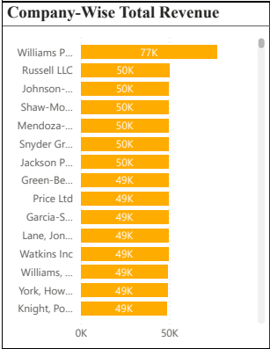
- Yearly, Quarterly, and Monthly Profit Analysis:
A line chart that tracks profit fluctuations across months and quarters over multiple years (2022–2024). Peaks and dips reflect profitable and low-performing periods.
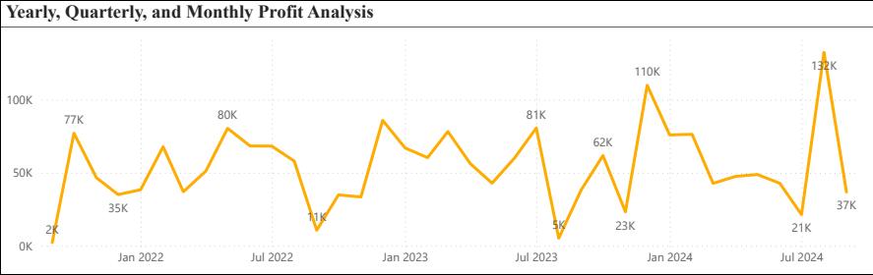

- Year-over-Year (YOY) Growth Trend:
A line chart showing the percentage change in profits from one year to the next. Positive values indicate growth, while negative values represent decline.
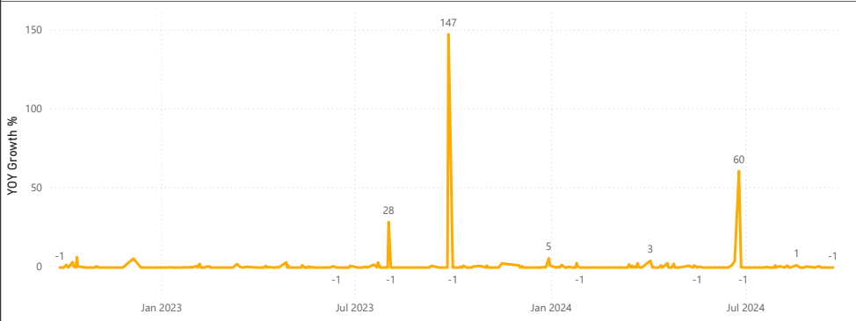
- EPS Trend by Year and Quarter:
A column chart showing Earnings Per Share for each year and quarter. This metric measures company profitability relative to the number of outstanding shares.
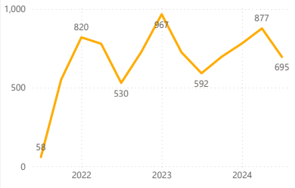

3. Dashboard 2: Company Performance Analysis
Description:
This dashboard focuses on profit efficiency, market performance, and comparative analysis between industries. It’s useful for management to assess operational effectiveness and shareholder returns.
Graphs Explained:
- Monthly Profit Trend:
A line chart illustrating profit month-by-month for a given year. It highlights seasonality and helps spot months of exceptional or poor performance.
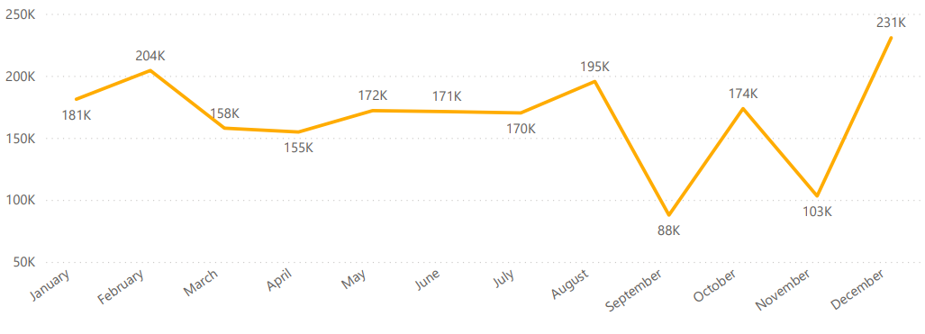
- Industry-Wise Average Earnings Per Share (EPS):
A bar chart comparing average EPS across industries like Technology, Retail, Energy, Healthcare, Finance, and Telecom. It reveals which sectors are most profitable.
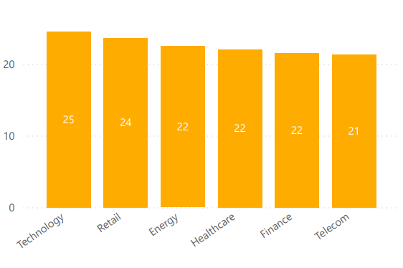

- Company-Wise Market Capitalization and Profit:
A scatter chart where each point represents a company, comparing its market capitalization (size) against its profit. Larger bubbles typically indicate stronger financial health.
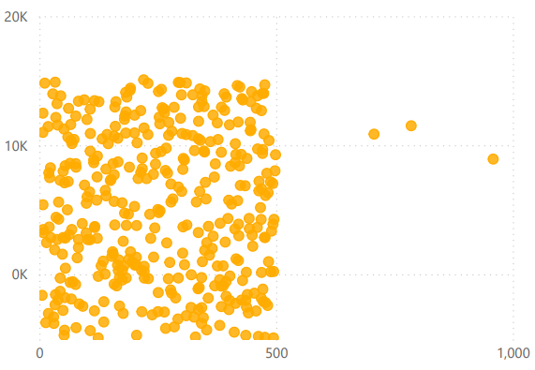
- Monthly Earnings Per Share (EPS) Trend:
A line chart tracking EPS values month-wise. It helps analyze the consistency of earnings and detect any sudden rises or drops.
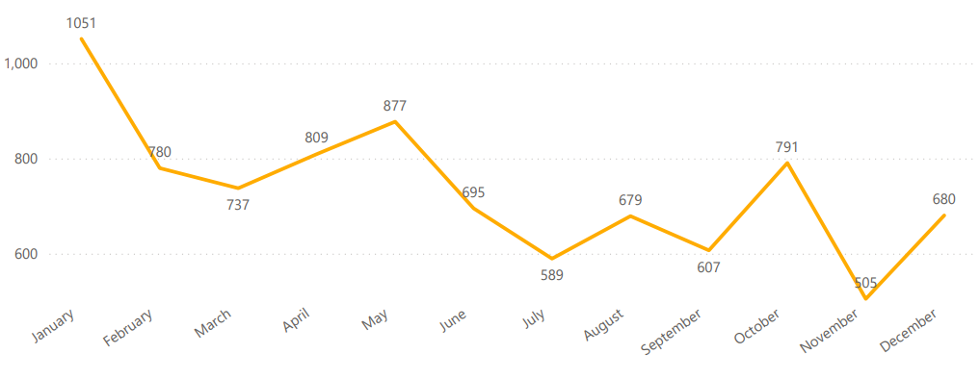

4. Dashboard 3: Stock Price & Volatility Analysis
Description:
This dashboard offers insights into stock market behavior — focusing on price trends, volatility, and trading volume. Financial analysts need to gauge risk and return patterns.
Graphs Explained:
- Company-Wise Stock Prices and Market Capitalization:
A clustered bar chart comparing each company’s open and close stock prices. It helps visualize how prices move during the trading cycle.
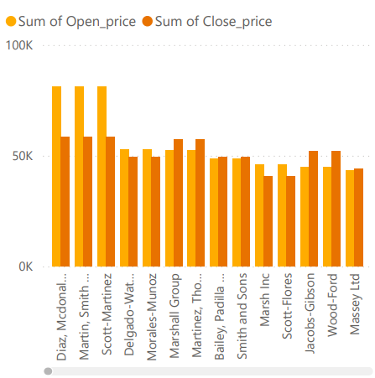
- Yearly and Quarterly Trends of Stock Prices and Profit:
A dual-axis line chart showing stock prices and profit trends over different time intervals (2022–2024). It indicates the relationship between profitability and stock performance.
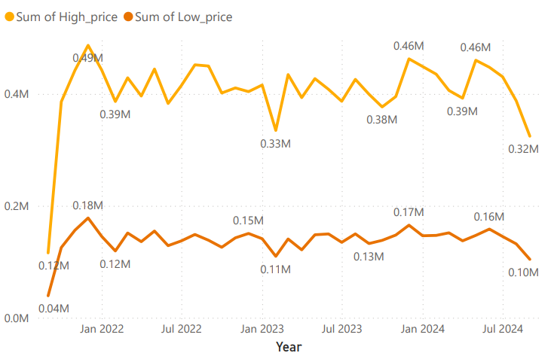

- Average Daily Volatility by Company:
A bar chart ranking companies based on daily volatility (price fluctuations). Higher bars indicate riskier, more unstable stocks.
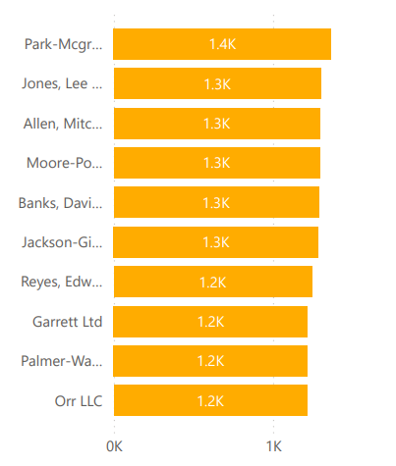
- Annual Trading Volume by Company:
A column chart displaying total trading volume for each company from 2021 to 2024. It measures how actively a company’s stock is traded.
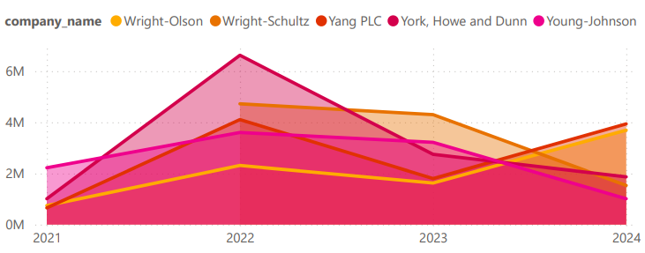
- Volatility, Trading Volume, and Market Cap by Industry:
A bubble chart combining three factors — volatility (x-axis), trading volume (y-axis), and market cap (bubble size) — to show overall market dynamics for each industry.
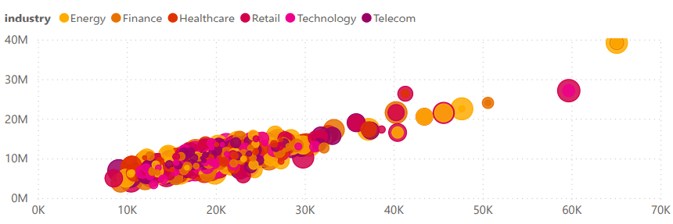

5. Dashboard 4: Trading & Transaction Insights
Description:
This dashboard examines trading patterns and transaction distributions, providing clarity on how investors interact with different companies and currencies.
Graphs Explained:
- Comparison of Buy and Sell Volumes Across Companies:
A clustered column chart comparing total buy and sell orders per company. It identifies companies with high investor demand or frequent sell-offs.
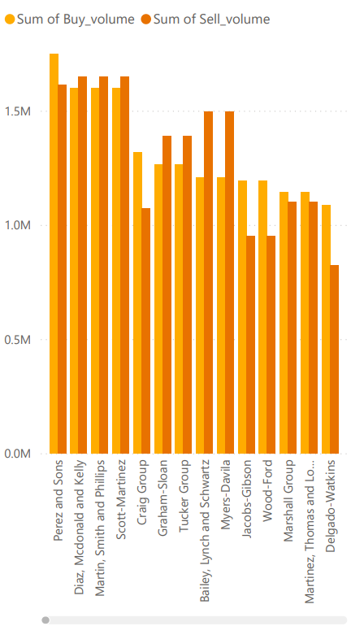
- Trend of Net Trading Volume by Month:
A line chart showing the net difference between buy and sell volumes across months. Positive values suggest buying pressure; negative values indicate selling dominance.
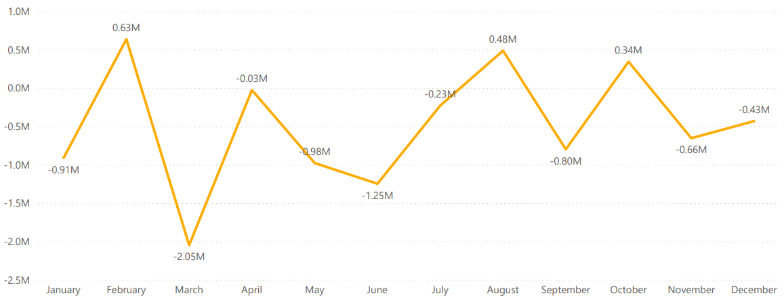
- Distribution of Transactions by Type:
A donut or pie chart showing the percentage share of transaction types — Buy, Sell, Split, and Dividend. It reveals investor activity preferences.
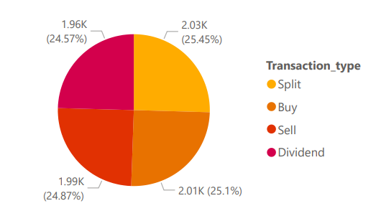
- Total Transaction Amount by Currency:
A bar chart summarizing total transaction values across major currencies (USD, JPY, EUR, GBP). This indicates the geographical spread and currency exposure of transactions.
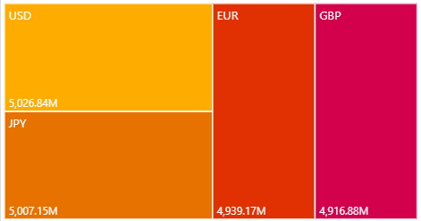

6. Conclusion
The Market Performance and Trading Insights project successfully achieved its objectives of designing an integrated data model, ensuring data quality, enabling analytical querying, and delivering meaningful visual insights through Power BI dashboards.
The dashboards provide a comprehensive overview of company performance, stock market trends, trading patterns, and financial relationships across multiple datasets. By integrating diverse market data into a unified analytical environment, the project demonstrates how business intelligence tools can transform raw data into actionable insights for effective decision-making.
6.1 Key Insights
The Power BI dashboards collectively reveal detailed insights into market performance and company financial behavior.
Major observations include:
- Consistent Revenue Growth: Most companies show steady revenue improvement across the years, with some experiencing seasonal peaks during mid-year quarters.
- Industry Performance Variation: Technology and Finance industries recorded the highest average Earnings Per Share (EPS), reflecting stronger profitability and investor appeal.
- Volatility Trends: Some companies exhibited higher daily stock price fluctuations, indicating greater risk but also higher potential rewards.
- Active Trading Patterns: Buy-side dominance in early quarters highlights strong investor confidence and market participation.
- Market Capitalization Stability: Market cap values remained aligned with profit trends, suggesting that operational success directly influences company valuation.
6.2 Business Implications
From a strategic standpoint, these findings demonstrate the power of data-driven financial monitoring and investment analysis.
Each user group benefits in different ways:
- For Management: The dashboards enable executives to track key performance indicators, compare profitability across business units, and allocate resources more efficiently.
- For Investors: Understanding EPS and volatility trends assists in optimizing portfolios and identifying stable, high-performing companies.
- For Financial Analysts: The integrated data supports accurate forecasting of market movements and investor sentiment.
- For Stakeholders: Transparent visual reporting promotes accountability, trust, and evidence-based decision-making across the organization.
6.3 Future Recommendations
To further strengthen and extend this analysis, the following steps are recommended:
- Integrate Real-Time Data: Connect live financial feeds and APIs to ensure up-to-date market insights.
- Expand Financial Metrics: Include advanced KPIs such as ROI, Debt-to-Equity Ratio, and Liquidity Ratios for more comprehensive financial analysis.
- Adopt Predictive Analytics: Apply machine learning models to forecast revenue trends, price movements, and investor behavior.
- Enable Automation: Schedule automated Power BI refreshes and create data alerts to notify users of significant market or company changes.
- Enhance User Interactivity: Add drill-through filters, slicers, and “what-if” scenarios for personalized exploration and better decision support.

7. References
7.1 Data Sources
- Sample financial dataset containing company revenue, profit, EPS, stock prices, trading volumes, and transaction records (2021–2024).
- Historical market and financial data compiled from open-source repositories and simulated corporate records for academic use.
- Reference data used solely for analysis, interpretation, and visualization within this Power BI project.
7.2 Analytical Tools Used
- Power BI Desktop: Used for data modelling, visualization, and DAX-based analytical calculations.
- Microsoft Excel: Employed for preliminary data cleaning, transformation, and dataset structuring before import.
- Power Query Editor: Utilized for data preparation, merging multiple datasets, and ensuring normalization.
- DAX (Data Analysis Expressions): Applied to calculate key measures, growth rates, and performance ratios.
- Visualization Techniques: Bar charts, line charts, scatter plots, donut charts, and KPI cards were used to communicate insights effectively.

